Map of colonial empires throughout the world in 1800

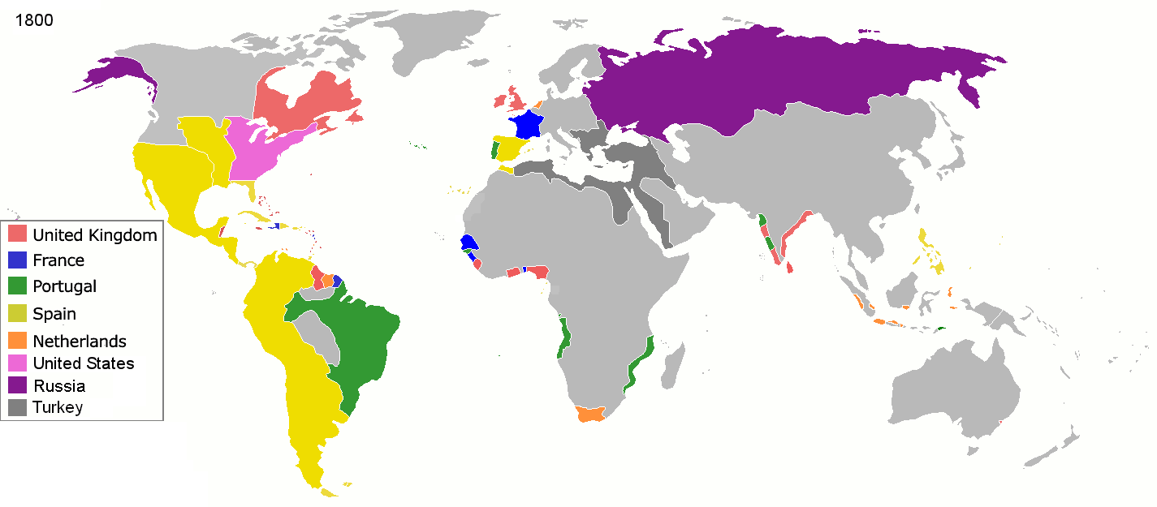

Map of colonial empires throughout the world in 1914

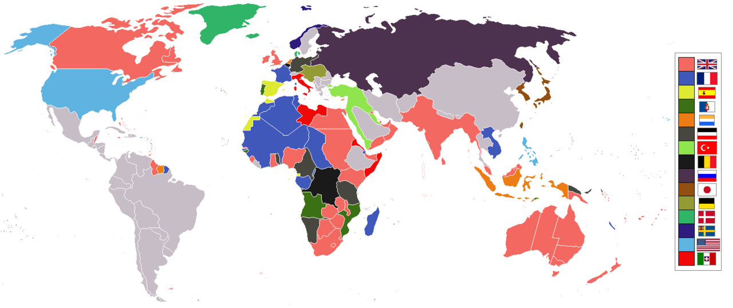

Map of colonial empires throughout the world in 1945

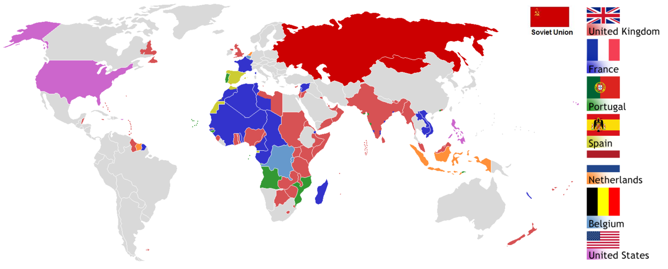

List of Colonisers and their colonised countries.

British colonies and protectorates
- Aden
- Anglo-Egyptian Sudan
- Ascension Island
- Australia
  - Australian Antarctic Territory
  - Christmas Island
  - Cocos Islands
  - Norfolk Island
- Bahamas
- Basutoland
- Bechuanaland
- British Antarctic Territory
- British East Africa
- British Guiana
- British Honduras
- British Hong Kong
- British Malaya
- British Somaliland
- Brunei
- Burma
- Canada
- Ceylon
- Cyprus (including Akrotiri and Dhekelia)
- Egypt
- Falkland Islands
- Fiji Islands
- Gambia
- Gilbert and Ellice Islands
- Gibraltar
- Gold Coast
- India (including what is today Pakistan and Bangladesh)
- Ireland
- Jamaica
- Kenya
- Malta
- Newfoundland
- New Zealand
  - Cook Islands
  - Niue
  - Ross Dependency
  - Tokelau
- Nigeria
- North Borneo
- Northern Rhodesia
- Oman
- Papua
- Sarawak
- Sierra Leone
- Southern Rhodesia
- St. Helena
- Swaziland
- Trinidad and Tobago
- Uganda
- South Africa

French colonies
- Algeria
- Clipperton Island
- Comoros Islands (including Mayotte)
- French Guiana
- French Equatorial Africa
  - Chad
  - Oubangui-Chari
  - French Congo
  - Gabon
- French India (Pondichéry, Chandernagor, Karikal, Mahé and Yanaon)
- French Indochina
  - Annam
  - Cambodia
  - Cochinchina
  - Laos
  - Tonkin
- French Polynesia
- French Somaliland
- French Southern and Antarctic Lands
- French West Africa
  - Benin
  - Côte d'Ivoire
  - Dahomey
  - Guinea
  - French Sudan
  - Mauritania
  - Niger
  - Senegal
  - Upper Volta
- Guadeloupe
  - Saint Barthélemy
  - Saint Martin
- La Réunion
- Madagascar
- Martinique
- French sMorocco
- New Caledonia
- Saint-Pierre-et-Miquelon
- Shanghai French Concession (similar concessions in Kouang-Tchéou-Wan, Tientsin, Hankéou)
- Tunisia
- Vanuatu
- Wallis-et-Futuna

Russian colonies and protectorates
- European Russia
  - Åland Islands
  - Baltic provinces
  - Bessarabia
  - Grand Principality of Finland
  - Chechnya
  - Chuvashia
  - Dagestan
  - Dnieper Ukraine
  - East Karelia
  - Ingushetia
  - Kabardino-Balkaria
  - Kalmykia
  - Karachay–Cherkessia
  - Komi
  - Mari El
  - Mordovia
  - Russian Poland
  - Tatarstan
  - Udmurtia
- Asiatic Russia
  - Adygea
  - Altai
  - Armenia
  - Azerbaijan
  - Bashkortostan
  - Buryatia
  - Chukotka
  - Emirate of Bukhara
  - Georgia (including Mengrelia)
  - Khakassia
  - Khanate of Khiva
  - Ossetia
  - Outer Manchuria
  - Russian Turkestan
  - Tannu Uriankhai
  - Yakutia
  - Yamalia

German colonies
- Cameroon
- Caroline Islands
- German New Guinea
- German East Africa
- German South West Africa
- Gilbert Islands
- Mariana Islands
- Marshall Islands
- Togo

Italian colonies
- Italian Eritrea
- Italian Aegean Islands
- Italian Somaliland
- Italian Concession of Tientsin
- Italian Libya

Dutch colonies
Curaçao and Dependencies
  - Aruba
  - Bonaire
  - Curaçao
  - Saba
  - Sint Eustatius
  - Saint Martin
- Dutch Guiana
- Dutch East Indies
- Dutch New Guinea

Portuguese colonies
- Azores
- Portuguese Africa
  - Cabinda
  - Madeira
  - Portuguese Angola
  - Portuguese Cape Verde
  - Portuguese Congo
  - Portuguese Guinea
  - Portuguese Mozambique
  - Portuguese São Tomé and Príncipe
  - Fort of São João Baptista de Ajudá
- Portuguese Asia
  - Portuguese India
    - Goa
    - Daman
    - Diu
    - Portuguese Macau
    - Portuguese Oceania
    - Portuguese Timor

Spanish colonies
- Annobón
- Balearic Islands
- Canary Islands
- Cape Juby
- Fernando Pó
- Ifni
- Rio de Oro
- Rio Muni
- Saguia el-Hamra
- Spanish Morocco (including Plazas de soberanía Ceuta and Melilla)

Austro-Hungarian colonies

Bosnia and Herzegovina
- Tianjin

Danish colonies
- Danish Virgin Islands
- Faroe islands
- Greenland
- Iceland

Belgian colonies
- Belgian Congo
- Tianjin

